BranchWise
What the application does, and how it reaches its numbers

1. The business, and the problem it had
The business runs four branches — one wholesale and three retail shops. Every retail shop has a point-of-sale system that prints out a daily report: what was sold, what is on the shelf, what was bought in. The reports were correct, and almost unusable.
- Each report was a printout, not a table — headers repeated in the middle of the page, totals and footers mixed in with the rows.
- The product names were written in two different Myanmar encodings — the same product could look like two different products.
- Nothing was ever brought together — comparing this month against last month, or one branch against another, meant opening several files and adding numbers up by hand.
- Problems were only noticed once they had cost money — a product that stopped selling, a shelf about to run empty, or a day whose file was never imported at all, were all found late or not at all.
So the owner had plenty of data and very little information. BranchWise was built to close that gap: not to store the reports, but to read them and say something useful about them.

2. The whole application in one picture
BranchWise does two quite different jobs, and it is worth separating them at the start of any demonstration, because one is simple and one is not.
The first job is clerical: take a messy daily report and turn it into clean records. This is the part the staff see, and it takes them about a minute a day.
The second job is analytical: read those records and judge the business. Nobody has to do anything for this to happen, and it is where almost all of the thinking in the project sits.
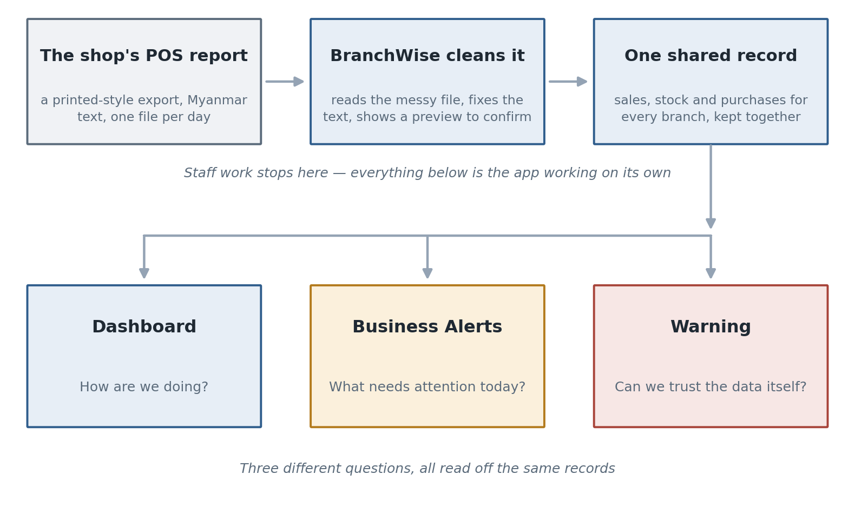
Figure 1 — One day's report becomes clean records, and three different pages then ask three different questions of them.
The three pages on the right are the ones that need explaining, because they look similar and are not:
- Dashboard — how is this branch doing? Revenue, profit, stock and customer behaviour, with an Overview that scores all of it.
- Business Alerts — what needs attention today, across every branch, as a short list of named problems.
- Warning — is the data itself trustworthy? Problems with the records, not with the business.
Keeping the third one separate is deliberate. A branch whose sales look terrible because a file was never imported does not have a sales problem; it has an import problem, and sending the manager to the shop floor over it would waste their day.

3. The simple half: one day's work
A branch's whole daily routine with the application is three steps.
Step | What the person does | What the application does
1. Upload | Chooses today's report file from the POS. | Reads the printout structure, ignores headers, totals and footers.
2. Check | Looks at the preview on screen. | Shows the cleaned rows next to the original ones, with Myanmar text corrected.
3. Confirm | Presses Confirm. | Saves the records under that branch, and keeps a record of the import itself.

Two things about this step are worth mentioning in a presentation, because they are what make the analytics half possible at all:
- Nothing is saved until a person confirms it. The preview is the safety step — what you see is exactly what will be stored.
- Every import can be undone. If a wrong file was confirmed, the branch reverts that import and confirms the corrected one. The record of the mistake stays, so the history is honest.

4. The hard half: turning records into a judgement
From here on, nobody presses anything. The application looks at the records and answers the question a manager actually has, which is not "what were the numbers" but "is this branch alright, and if not, what part of it isn't".

4.1 Five questions instead of one number
A single "performance score" would be useless: a branch can be selling well and quietly going bankrupt on thin margins, or profitable while its shelves empty. So the health of a branch is measured in five separate areas, each scored out of 100, and only then combined.
Area | Weight | The question it answers
Sales | 25% | Is the branch selling more or less than the period before?
Profit | 25% | Is what it sells actually making money, and is that improving?
Inventory | 25% | Is stock moving, and is anything about to run out?
Customer | 15% | Are shoppers buying more per visit, or making smaller trips?
Data quality | 10% | Can the four scores above be trusted?

The last row is the unusual one, and it is the one to point at during a presentation. The application scores its own data as part of the branch's health, because a score built on records with missing days or impossible prices is worse than no score at all.
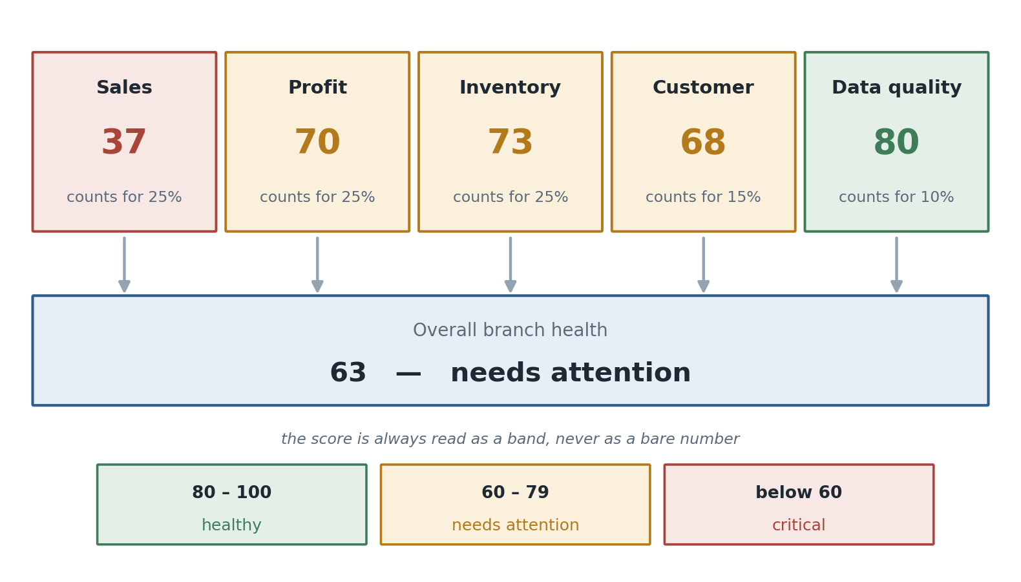
Figure 2 — Five area scores, weighted, become one overall score — which is then read as a band rather than as a bare number.

4.2 How a raw number becomes a score out of 100
Each area is itself made of two or three measures. Every measure is turned into a 0–100 score by a small table of reference points, and anything between two points is placed proportionally between them.
Revenue growth against the period before | Score it earns
−20% or worse | 0
−10% | 40
no change | 70
+10% or better | 100

Two choices in that little table are worth defending out loud. Flat growth scores 70, not 100 — standing still is acceptable, not excellent. And the score is written against each reference point rather than derived from a direction, which lets the same mechanism handle measures where less is better (dead stock) and even measures with a healthy middle: days of stock on hand scores best at about a month, and falls away on both sides — two weeks of cover is a shelf about to empty, two months is cash sitting on it.
The full set of measures behind the five areas:
Area | Measures it is built from
Sales | Revenue growth (50%), transaction growth (30%), average sale growth (20%)
Profit | Gross margin (60%), change in margin (40%)
Inventory | Dead stock share (40%), stock-out risk share (30%), days of stock on hand (30%)
Customer | Items per basket growth (55%), single-item basket share (45%)
Data quality | Issues per 100 records (70%), stock mismatches (30%)

4.3 Two rules that keep the score honest
Nothing is measured twice. The Overview does not calculate anything of its own — it reads the very same figures the Revenue, Cost, Inventory and Customer pages show. If a red Inventory score sent a manager to an Inventory page reporting a different dead-stock count, neither number would ever be trusted again.
Something that cannot be measured is left blank, never scored as zero. A branch with no previous month has no growth to measure. A product with no buying price has no margin to measure. Scoring either as 0 would tell a manager their branch is failing when the truth is that it was never measured — the most damaging thing a score like this can do. Instead the measure drops out, the remaining weights are shared out again, and the page says in plain words what is missing and what to import to fix it.

5. What needs attention today: Business Alerts
The score says which part of a branch is unhealthy. It does not say what to do. That is a second engine: a set of rules, each watching one subject, each producing a named problem with an action attached.
The alert | It appears when | How serious
No sales recorded | A period with no sales at all, after one that had them | Critical
Revenue is falling | Revenue is more than 10% down (20% escalates it) | Warning / Critical
Margin is too low | Gross margin below 10% (below 5% escalates it) | Warning / Critical
Margin is slipping | Margin fell by 3 percentage points or more | Warning
Stock about to run out | A product has 3 days of stock left or less | Critical
Stock running low | A product has less than 7 days of stock left | Warning
Dead stock | A tenth or more of the products on the shelf sold nothing in 90 days | Warning / Critical
Fewer customers coming | Visits down 10%+ while bigger baskets hid it in the takings | Warning
Single-item baskets | 60% or more of receipts had only one item on them | Warning

Three ideas hold that list together, and they are what separate it from a wall of notifications nobody reads.
- One rule owns one subject. A margin below the floor and a margin that is slipping are the same conversation, so only the worse of the two is reported. The same goes for a shelf about to empty versus one merely running low.
- An empty period is reported as a missing file, not as a collapse. Sales of zero after a normal month is almost always a report nobody imported.
- There is no third, mild severity level. A list where everything is worth mentioning is a list nobody reads.

5.1 What one alert actually says
An alert that only said "revenue is down 12.9%" would be telling the manager something they could read off a chart. So every alert is written in four parts, in the order a reader asks for them.
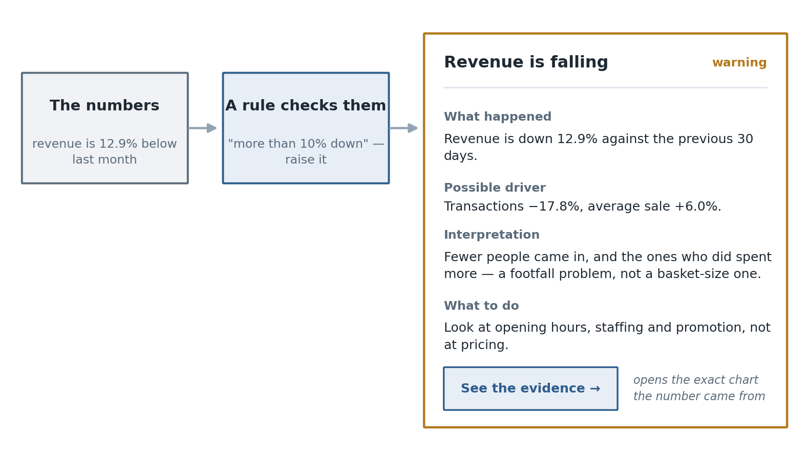
Figure 3 — The same alert, from the rule that raises it to the action it asks for. The button opens the exact page the figures came from.

5.2 Why it happened — and why that is arithmetic, not an opinion
The middle two parts of that alert are the interesting ones, because two very different situations produce the identical headline "revenue is down 12.9%":
- Fewer people came in, and the ones who did spent normally — a marketing, opening hours or staffing problem.
- The same people came in and spent less each — a pricing, placement or stock problem.
Those call for opposite decisions, so the application separates them by splitting the change itself. Revenue is only ever visits multiplied by the average basket, so a change in revenue can be split into the part caused by the change in visits, the part caused by the change in basket size, and the small piece where both moved at once.
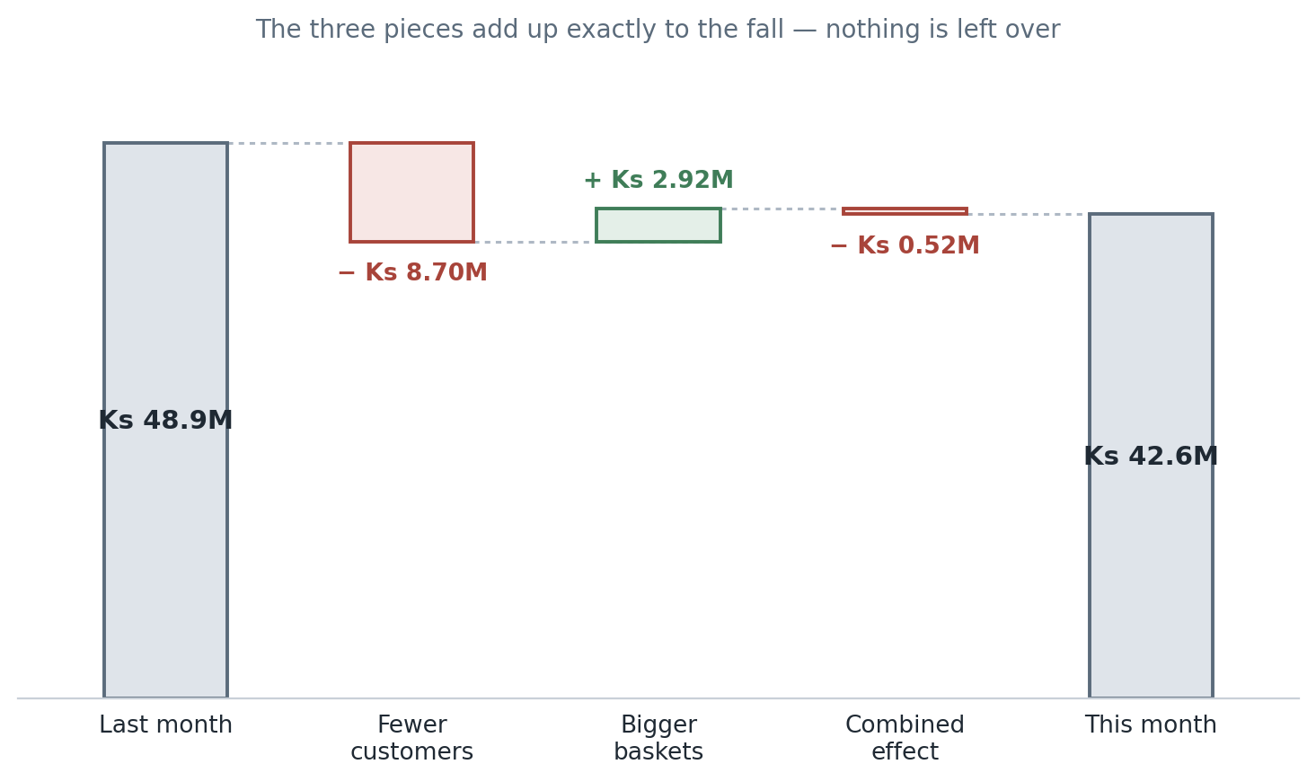
Figure 4 — Last month's revenue, the three effects that moved it, and this month's. The pieces sum exactly to the fall.
This is the sentence to say to an examiner: the three pieces add back up to the actual change with nothing left over, so whichever is bigger is the cause — it is measured, not guessed. Nothing here asks a language model what it thinks, and every sentence in every alert is a template filled with these figures.
The application only names one of them as "the" driver when it accounts for about two thirds or more of the movement. Below that, the honest answer is that both are contributing, and it says so rather than picking a winner by a nose.
The same treatment is applied elsewhere. A stock warning is split into whether sales sped up or stock ran down — reorder more, versus reorder sooner. A margin problem is split into whether costs rose, prices fell, or both. And a low margin or a high share of single-item baskets is checked against the months before, because the question that changes the decision is whether it is new.

6. Can we trust the data: the Warning page
The Warning page is the odd one out, and the easiest to explain badly. It is not about the business at all. It checks whether the records themselves make sense, and it exists because every number on every other page is only as good as they are.
What it checks | What it looks for
Sale records | Prices, quantities or amounts that cannot be right — a negative price, a zero quantity
Inventory records | The same kind of impossible values on the latest stock count
Purchase records | The same again, on what was bought in
Missing products | A product that was sold or bought but has no stock record at all
Daily check | Whether the counted stock matches what the records say it should be

The last one is the check worth demonstrating, because it is the one that catches a missing file rather than a typing mistake.
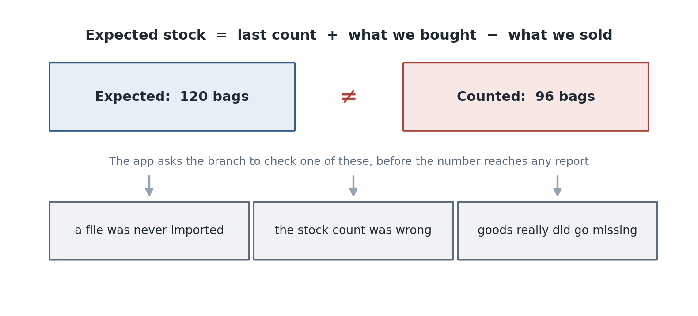
Figure 5 — The daily check: what the records say the shelf should hold, against what was counted.
Every row on this page says, in plain words, what looks wrong and which field is at fault, and — where the problem can be traced to one import — links straight back to it. The fix is almost always the same loop: revert that import, correct the file, confirm it again.
A limitation stated openly
The daily check compares quantities without converting between units of measure. When one product has been recorded in mixed units, the application says so and asks for a manual check, instead of reporting a mismatch it is not sure about. Admitting that is better than a false alarm — and in this business's real data, units are always "Each" anyway, so a mismatch there is a data-entry mistake rather than a conversion problem.

Because these checks run over every record, they are also given a date window that the business can set. By default the sale and purchase checks look at today only, which is why the page can look empty when someone is investigating something from last month — the window, not the data, is what is hiding it.

7. Putting it together: one branch, one month
This is the part to walk through slowly. Everything below is one retail branch over 30 days, compared against the 30 days before it.

What the records showed
 | This month | Month before | Change
Revenue | Ks 42,600,000 | Ks 48,900,000 | −12.9%
Transactions | 3,120 | 3,795 | −17.8%
Average sale | Ks 13,654 | Ks 12,885 | +6.0%
Gross margin | 18.4% | 19.6% | −1.2 points
Dead stock | 11% of products | — | —
Stock warnings | 1 product with 2 days left | — | —

What the application made of it
Area | Score | Why
Sales | 37 | Revenue and visits both fell close to the bottom of their bands
Profit | 70 | Margin is healthy enough and barely moved
Inventory | 73 | Stock cover is about right; dead stock is the weak part
Customer | 68 | Baskets slightly smaller, half of receipts single-item
Data quality | 80 | Under one issue per 100 records, two stock mismatches
Overall | 63 — needs attention | The weighted result of the five above

This is the moment the whole design pays off. The overall 63 looks merely mediocre; the Sales 37 underneath it is a serious problem. A single headline score would have hidden that, which is exactly why the branch is scored in five parts and the parts are always shown.

What it asked the branch to do
Alert | What it said | What to do
Stock about to run out (critical) | One product has 2 days of stock left, and it is selling more than twice as fast as before | Reorder more, not just sooner
Revenue is falling (warning) | Down 12.9%; visits −17.8% while the average sale rose 6.0% — a footfall problem | Opening hours, staffing, promotion — not pricing
Dead stock (warning) | 11% of the products on the shelf sold nothing in 90 days | Clear or discount them; that is cash on a shelf

Notice what did not appear. No "fewer customers" alert was raised, even though customers clearly fell — because the revenue alert had already explained that in the same words, and repeating it would only push something else off the screen. That alert is saved for the genuinely hidden case: takings that look fine because bigger baskets covered for the people who stopped coming.

8. Why it is built this way
Five points worth ending a presentation on.
- Every number is computed, not generated. Every sentence in every alert is a fixed template filled with measured figures. Nothing asks a language model for an opinion, so nothing can be confidently wrong.
- Every number can be opened. A score shows the measures under it, each measure shows the figures it came from and the table it was scored against, and each alert links to the page holding its evidence. A number nobody can inspect is a number nobody can argue with — or correct.
- The thresholds belong to the business, not to the programmer. The weights of the five areas and the point at which each alert fires are settings an administrator can change. That turns "are these the right weights?" from an argument into a test: score the same branch twice and compare.
- Unmeasured is never zero. Anything that cannot be measured drops out and says why, rather than quietly scoring nothing.
- Data quality is part of the judgement, not a separate hobby. It carries its own weight in the score, and the business problems and the data problems are kept on different pages because different people fix them.

9. Questions you may be asked

Isn't this just a dashboard?
A dashboard reports numbers and leaves the reading to you. This scores them, names what is wrong, splits the cause arithmetically, and says what to do — and it scores the reliability of its own inputs while doing it.

Where do the weights and thresholds come from?
They are a considered starting point, and they are settings rather than fixed rules — an administrator changes them, and the same branch can be scored under two sets and compared.

Is any of this AI-generated?
No. Every alert sentence is a template filled with measured figures, and the cause of a change is a decomposition that adds back up exactly. That is why it can be checked by hand.

What happens when data is missing?
The affected measure is left blank and says what is missing; the remaining weights are shared out again. It is never scored as zero.

Why is 'Warning' separate from 'Business Alerts'?
One is the business going wrong, the other is the records being wrong. They are read by different people, and the fix for one is a business decision while the fix for the other is re-importing a file.

Why does the wholesale branch not appear on any of this?
Wholesale does not run a point-of-sale system — its orders are entered directly, so it has none of the imported data these pages read. That is expected, not a gap.

